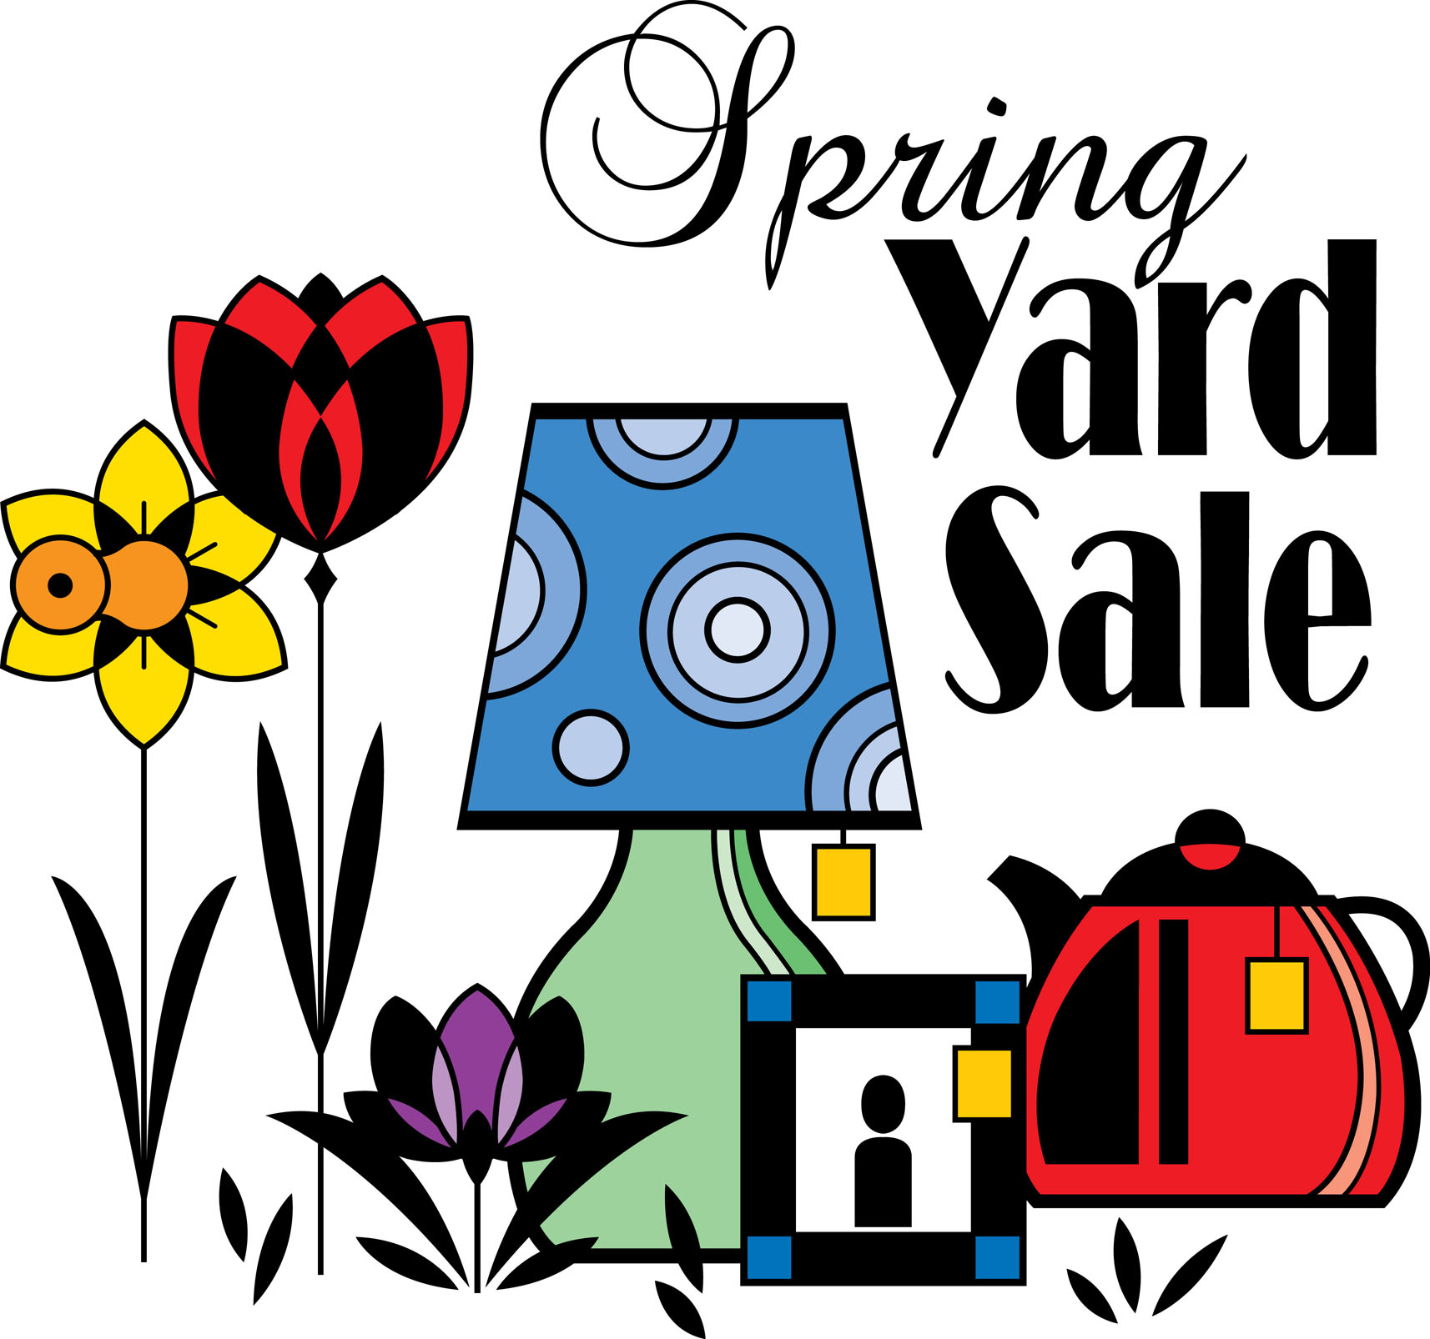

COMMUNITY YARD SALE – Saturday May 19th!

Reminder to start go through your treasures!
This spring’s sale will also be sponsored by: Erin Andrews from Allen Tate Real Estate!

